Engineer spare return – RECEIPT APPROVAL TO REVERSAL SO DO

Engineer submit the spare return form .

Then return receipt will be generated and assigned to the respective parts coordinatror

Parts coordinator do the following steps

URL- <https://mcis.deltaiserve.net/>

1)Type the URL , enter the login credential and do the login

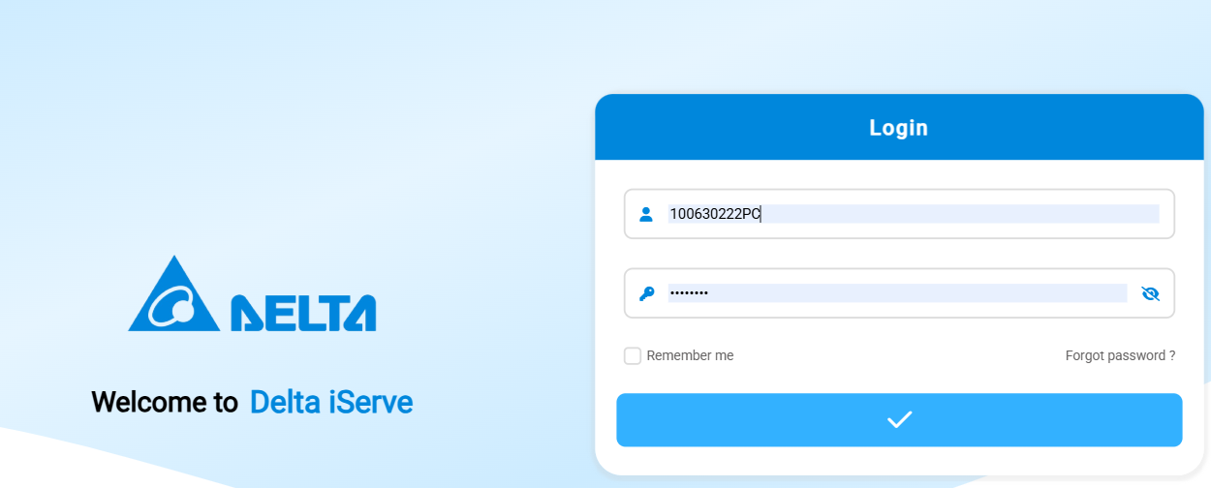

GO TO spare return module and see the assigned return ticket

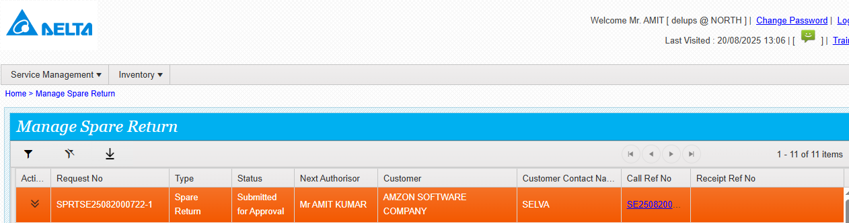

Click on approve

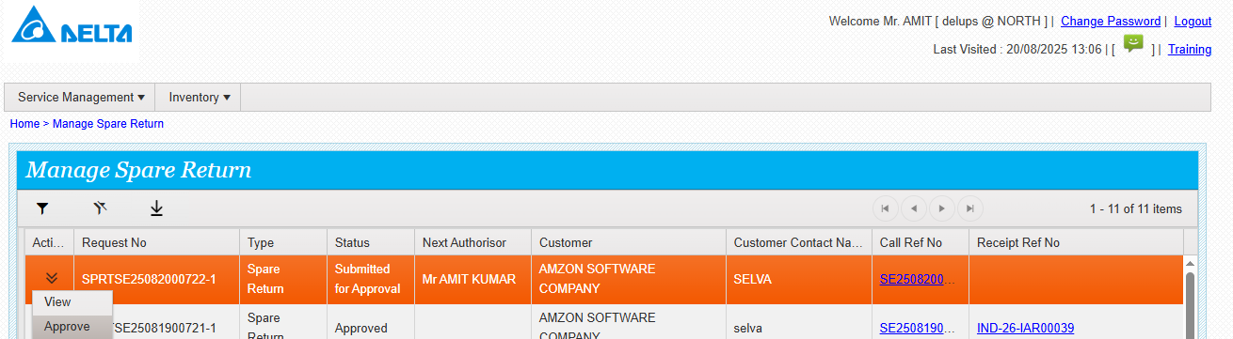

Approved done successfully

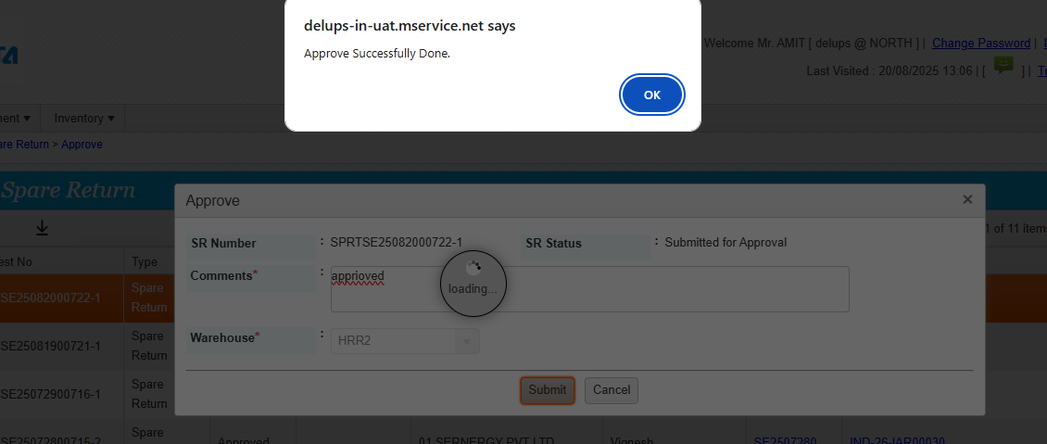

Once approved then receipt will be generated.

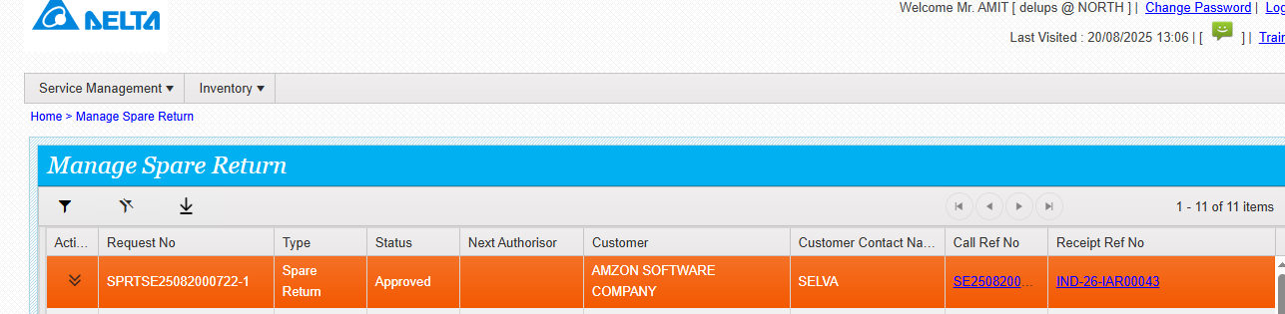

Receipt assigned to the respective parts coordinator

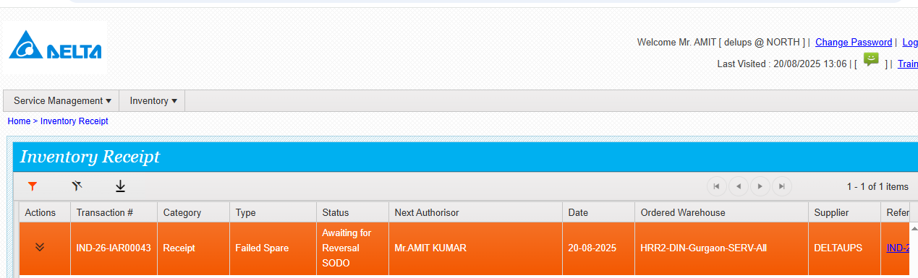

Click on actions and see the actions available

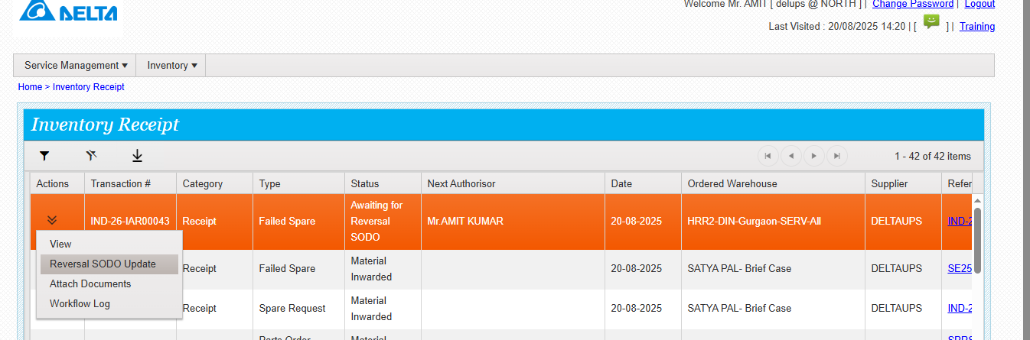

Click on reversal SO DO and update the required details

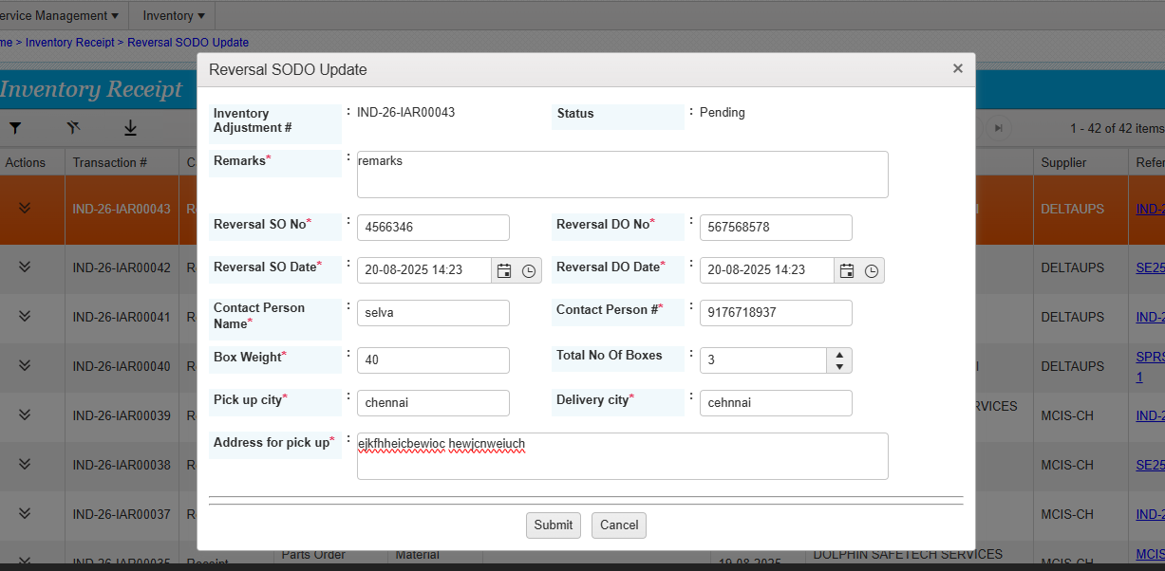

Reversal SO DO done successfully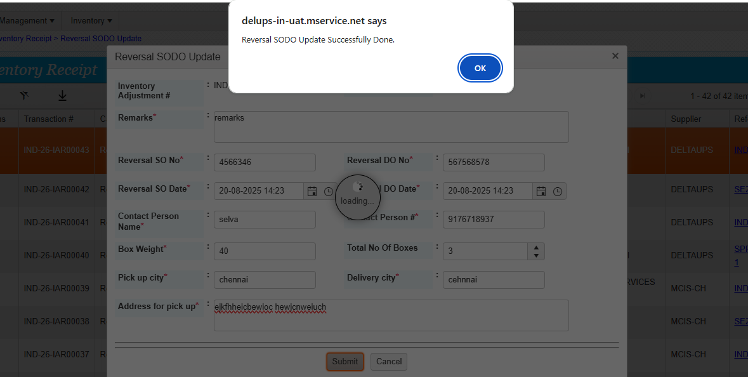

Now the status is awaiting reversal pick pack assigned to the logistics coordinator

